**Mobius Unity Flappy IOS Documentation**

* If you don’t have unity install on your system. Go to this link

**https://unity3d.com/get-unity/download/archive** and download Unity. If you have Windows operating system then Download (Win) and in case of Mac Download (Mac)

Try to install Unity 2017.3.1 version. As it is the most stable version

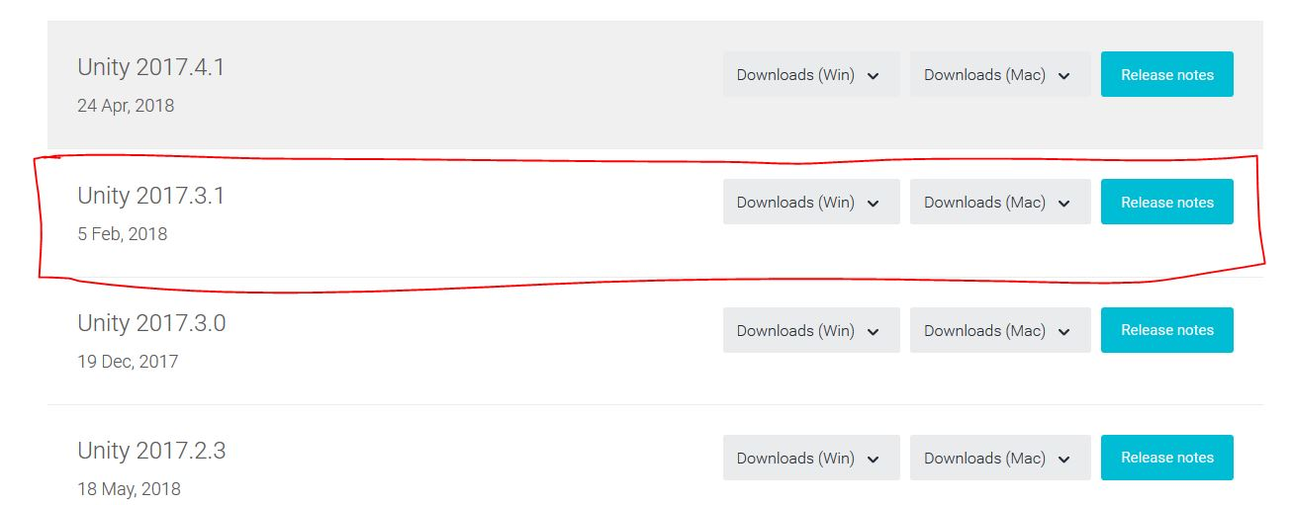

* Now when you successfully install the Unity. Clone or download the project from repo you have folder with name “mobius-client-unity”. Open this folder in unity.

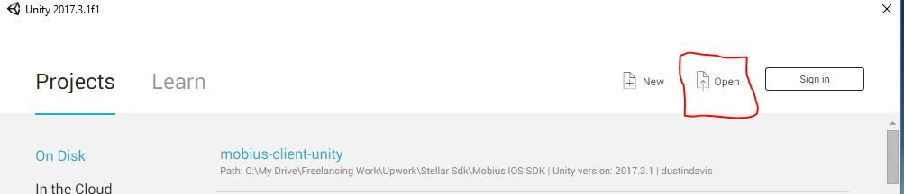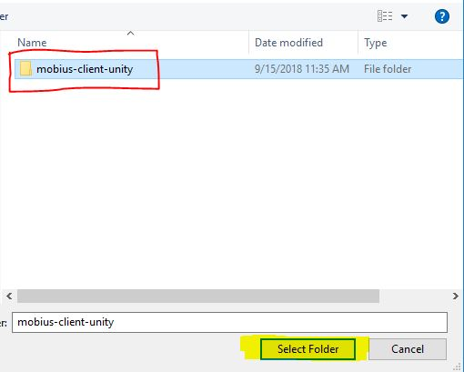

* Now after open the project. Goto File->BuildSetting. Window will appear here you will see iOS platform. Select that platform and then press switch platform and then wait for while unity will convert project for iOS platform.

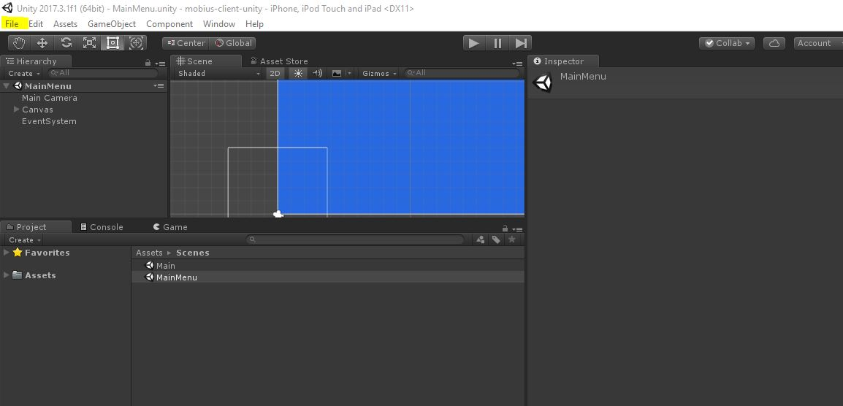

* Now Press the play button to play game in editor. But you won’t able to test the payment transaction in unity you have to build for iOS device to test the project.

1. Here is the first screen of the app.

User will enter it’s secret key and then login. If key is valid 5 credits will be taken from user account and user can play the game. If you don’t want to enter secret key there is “Get Dummy Secret Key For Testing” that when you press you can login and play the game.

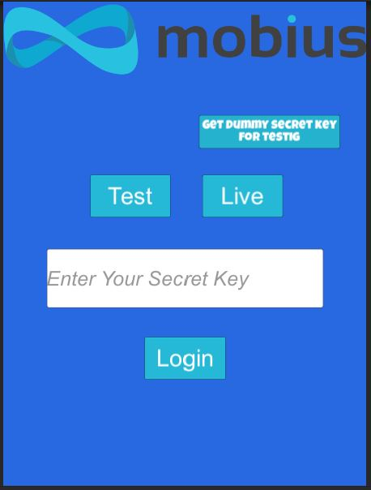

1. The owner have to put it’s public key inside the unity editor. So that payment will directly transfer to owner. Owner can also enter the number of credits that owner want to deduct from user.

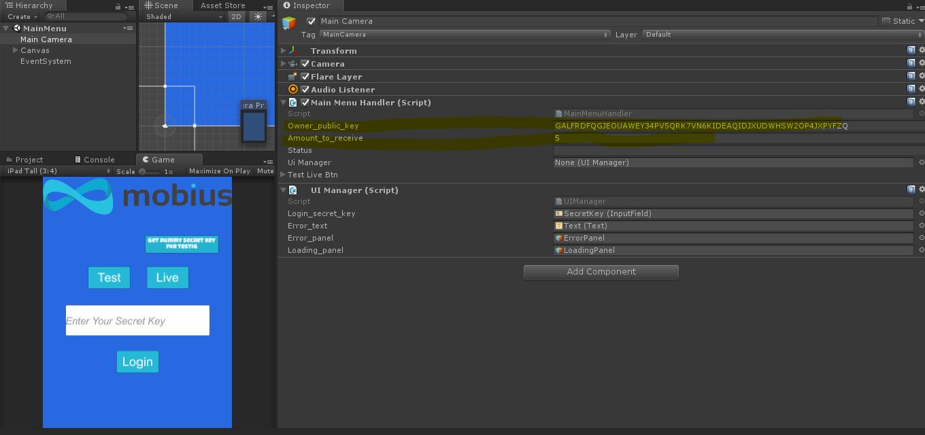

1. After successful login. You’ll see your balance at top of the screen and you score at bottom of the screen. If you die or game over. Game over panel appear. If user press Retry button 5 credits deduct from user and transfer to owner account and user can play the game again.

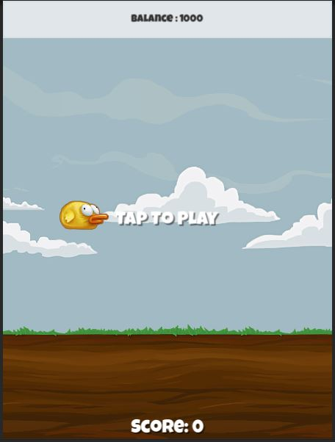

1. Now it is all done with Unity Editor. Now We have to build the game and test on our iOS device. Now Again goto “File->BuildSetting”. Window will appear and there build button. Click on it and wait for the Unity to build game for iOS platform.

**From Xcode:**

* I have already put Xcode project in repo. Having Folder name

**mobius-client-unity-xcode**

* Now place the pod file in that folder. The **Podfile** is in the documentation folder.



* open terminal window on mac and run command cd “path of folder” like cd “/Users/asad/Desktop/unity”

Or write cd and drag folder in terminal

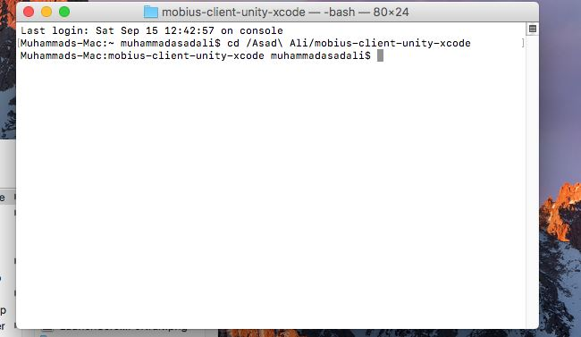

* run command pod install

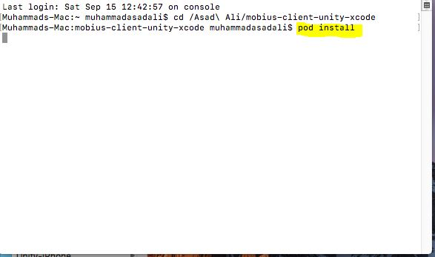

* after install pod open Unity-iPhone.xcworkspace file

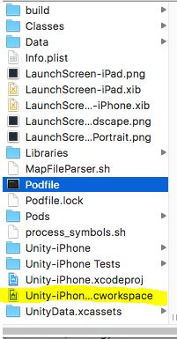

* Now when xcodeworkspace open. Connect your iOS device and run the project and all things work fine. You can do transaction and get balance.

Please let me know if any confusion or help you need from my side. I’ll try to show my availability at my earliest. Thanks